Jenkins Assignment

Q. Create a Jenkins Job in a

(i) freestyle Type

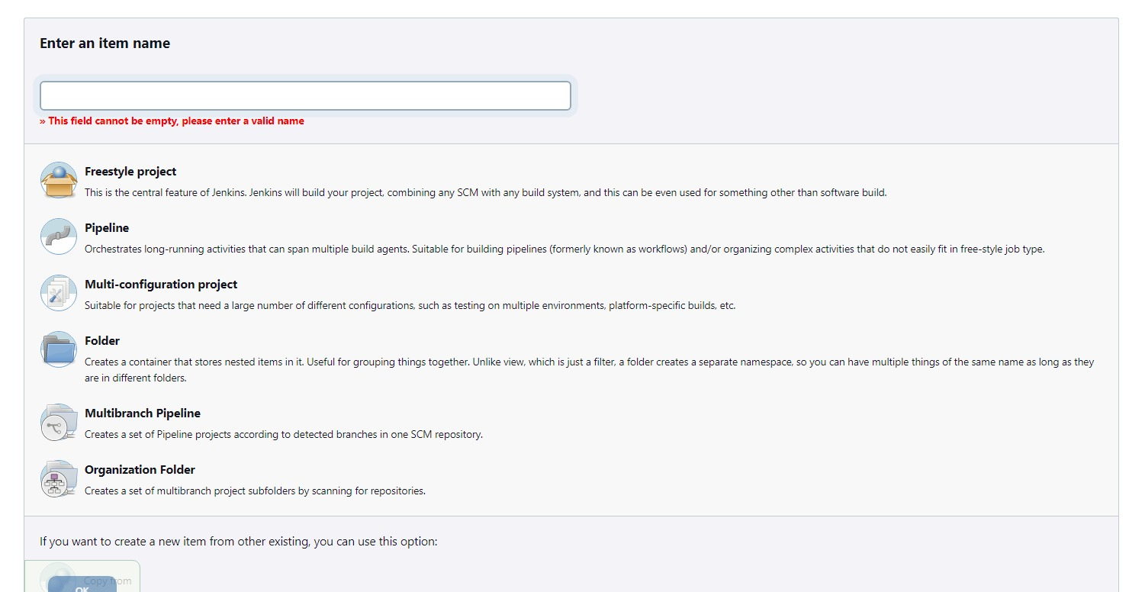

Q. Demonstrate the following

(i) Build Triggers w.r.t SCM

(ii) Integration with Git

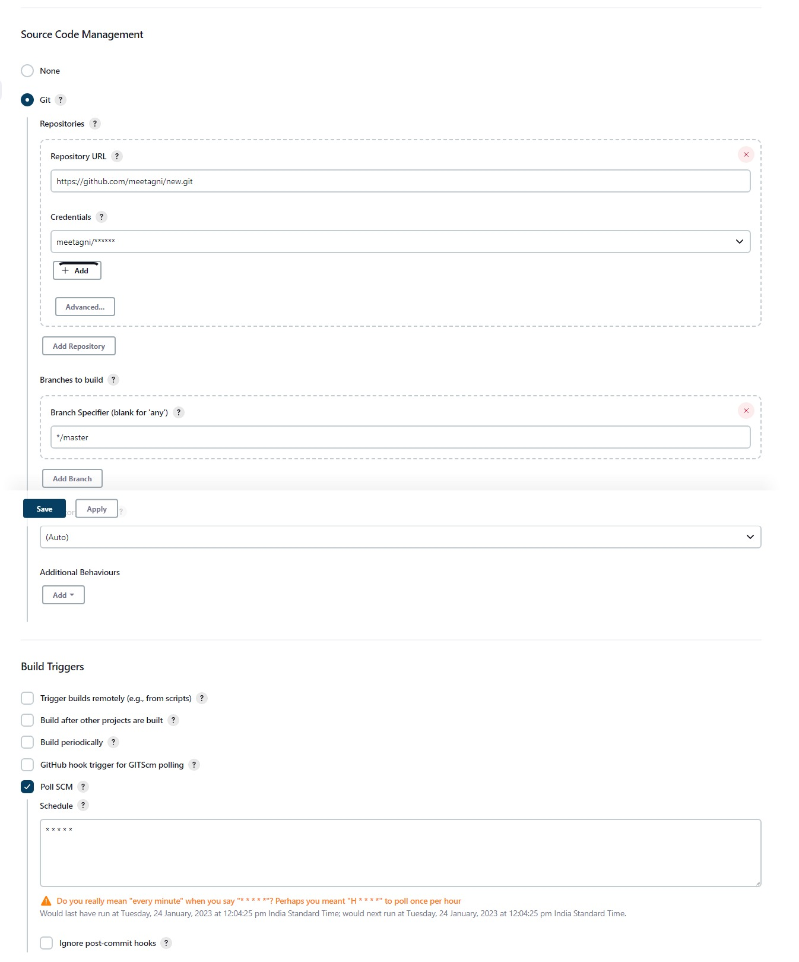

Create a Repository on Git and connect the created

branch b1 with the Jenkins and ensure the automation

on the build via any changes pushed to the github.

